Fake New Detection System
Design Document

Version 1.0



Group Id: F25PROJECT5A938

Supervisor Name: Huma Mumtaz

Revision History
Date (dd/mm/yyyy) | Version | Description | Author
23/1/26 | 1.0 | Introduction of the project
 |  |  | bc220413756 bc220413177

Table of Contents

- Introduction of Design Document
- Entity Relationship Diagram (ERD)
- Sequence Diagrams
- Architecture Design Diagram
- Class Diagram
- Database Design
- Interface Design
- Test Cases

- Introduction of Design Document
This Design Document provides a comprehensive description of the system architecture, components, data flow, and technical specifications of the proposed software solution. It serves as a blueprint for the development phase by translating system requirements into a structured and well-defined design. The document includes high-level and low-level design details such as system architecture, module descriptions, database design, user interface layouts, and interaction diagrams.

The primary purpose of this design phase is to establish a clear understanding of how the system will be built before actual development begins. By defining the system structure and behavior in advance, this document helps ensure that all stakeholders—including developers, designers, and project managers—share a common vision of the solution. It reduces ambiguity, minimizes implementation errors, and supports effective communication within the development team.

Additionally, this design document plays a critical role in identifying potential technical risks and constraints early in the project lifecycle. It enables better planning, estimation, and resource allocation, thereby improving overall project efficiency. The design phase also facilitates easier maintenance, scalability, and future enhancements by promoting modular and well-organized system architecture.

In summary, this document acts as a reference guide throughout the software development lifecycle, ensuring that the final system meets functional and non-functional requirements while maintaining quality, reliability, and performance standards.

- Entity Relationship Diagram (ERD):
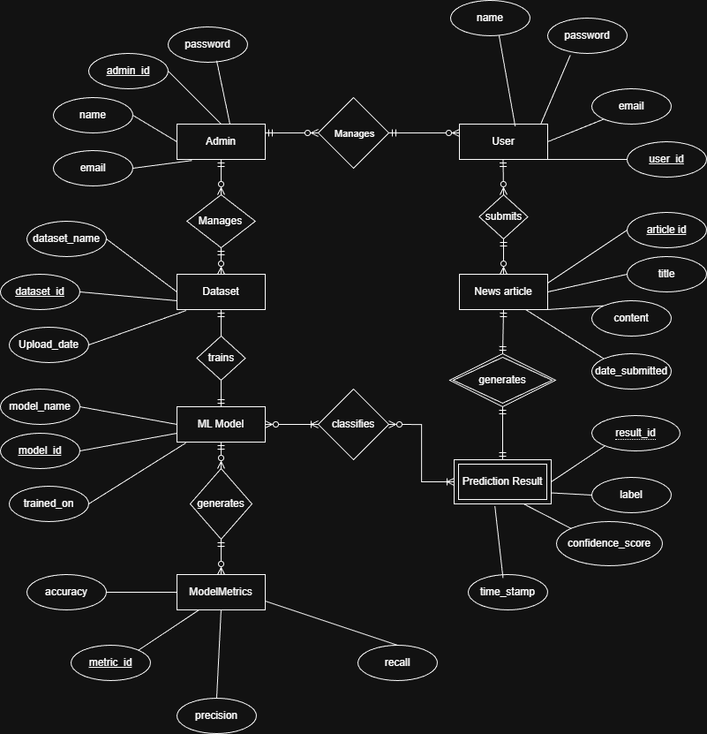

- Sequence Diagrams
- User Registration
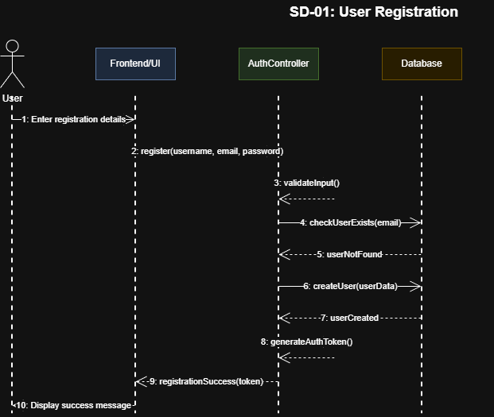

- User Login
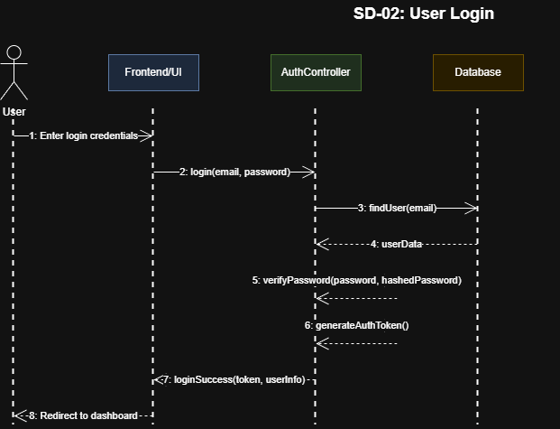
- Analyze News Article
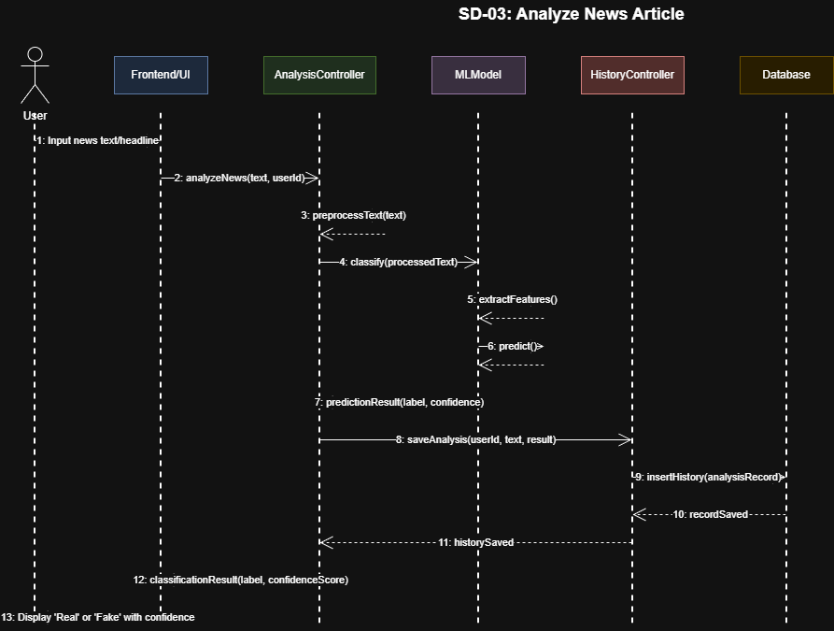

- View Analysis History
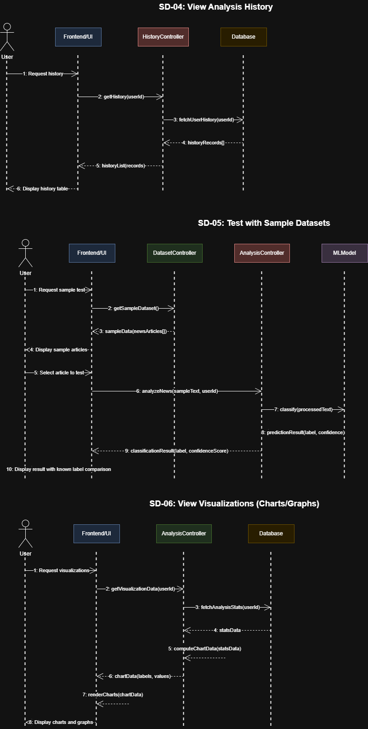

- Test with Sample Datasets
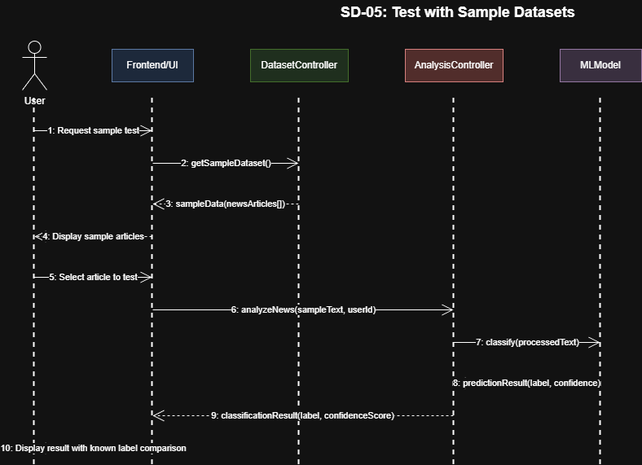

- View Visualizations
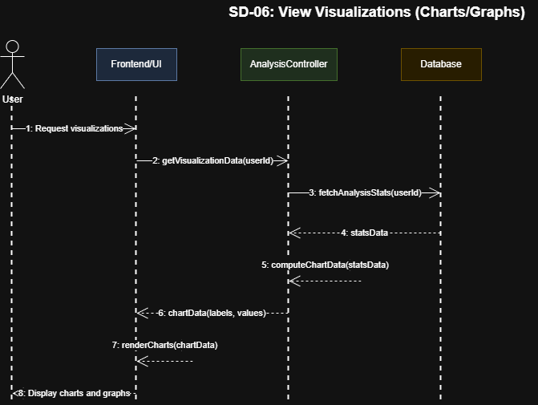

- Export Results
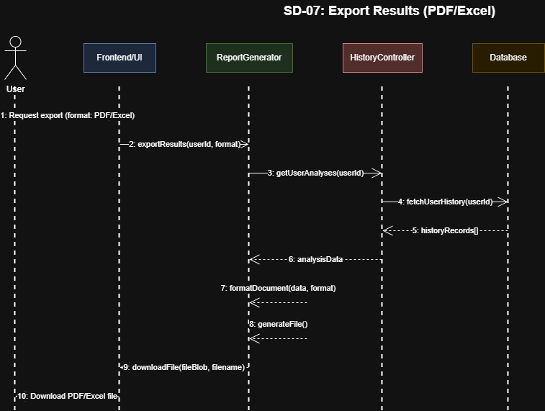

- Admin - Add User
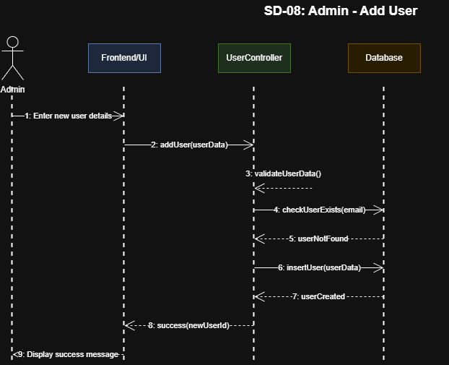

- Admin – Update User
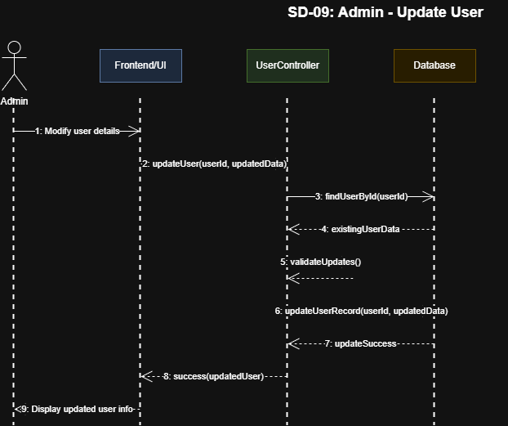

- Admin – Delete User

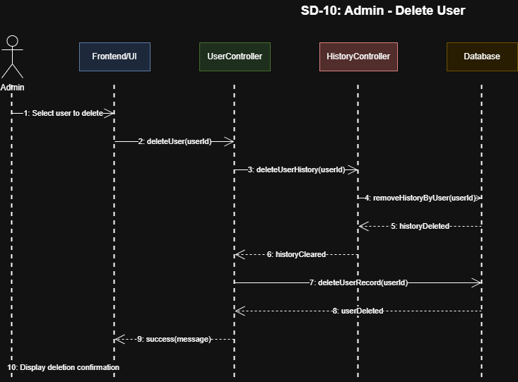

- Admin – Upload Dataset
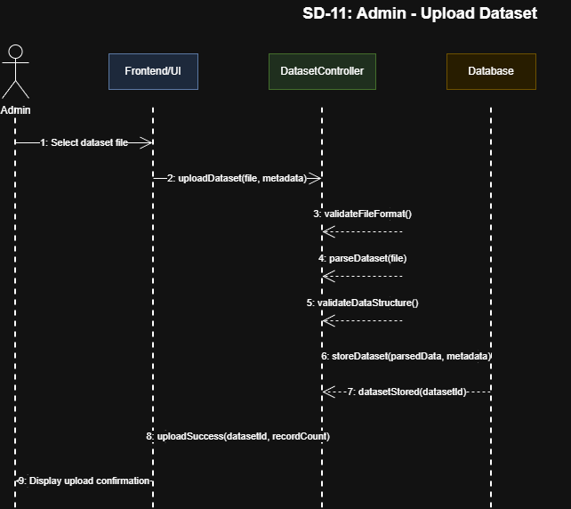

- Admin – Retrain Model
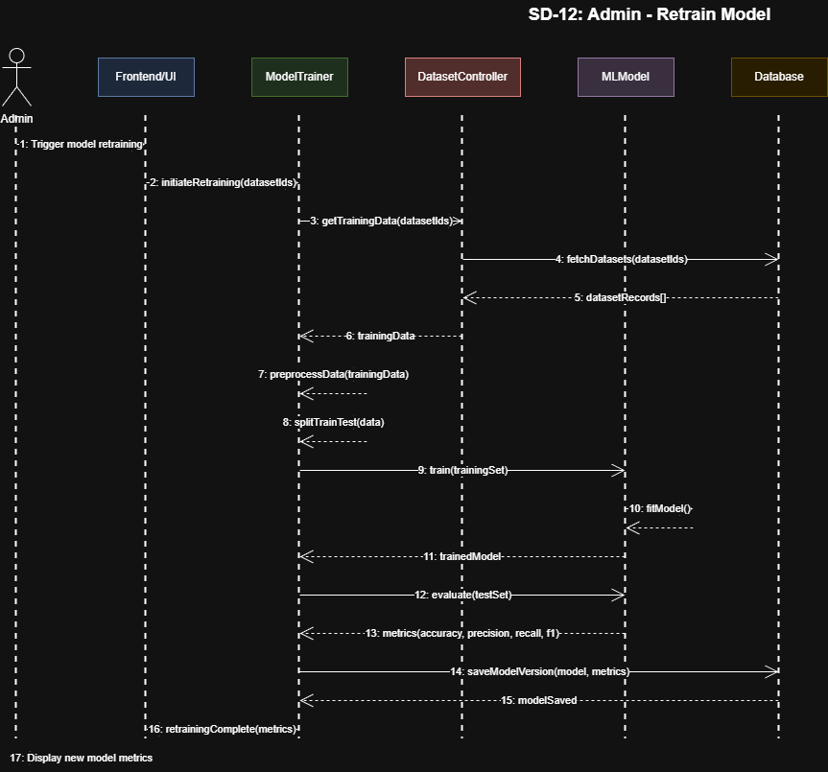

- Admin – View System Metrics
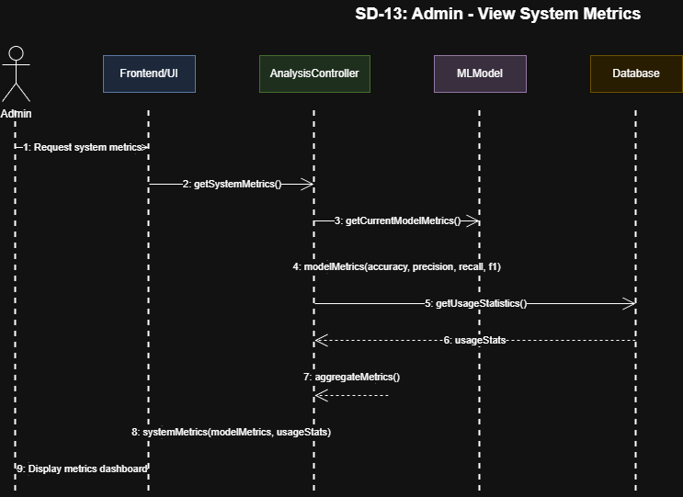

- Admin – Generate Reports
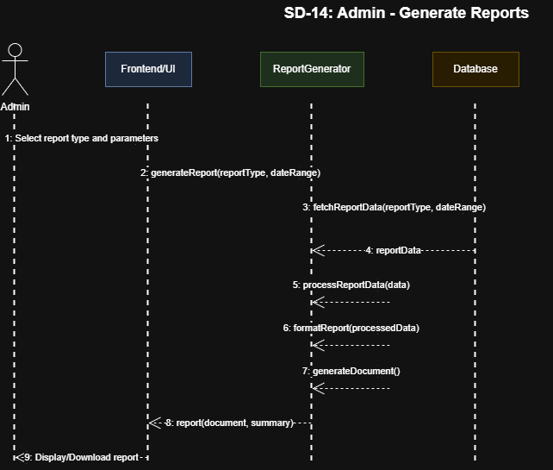

- Admin – Delete History
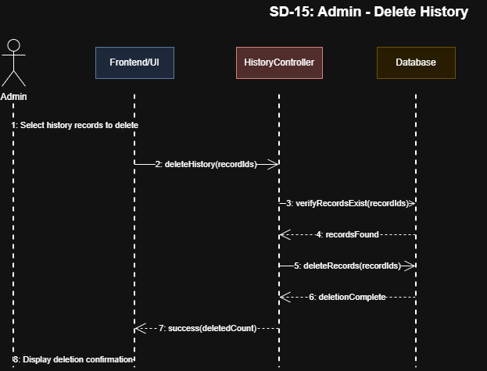

- Architecture Design Diagram
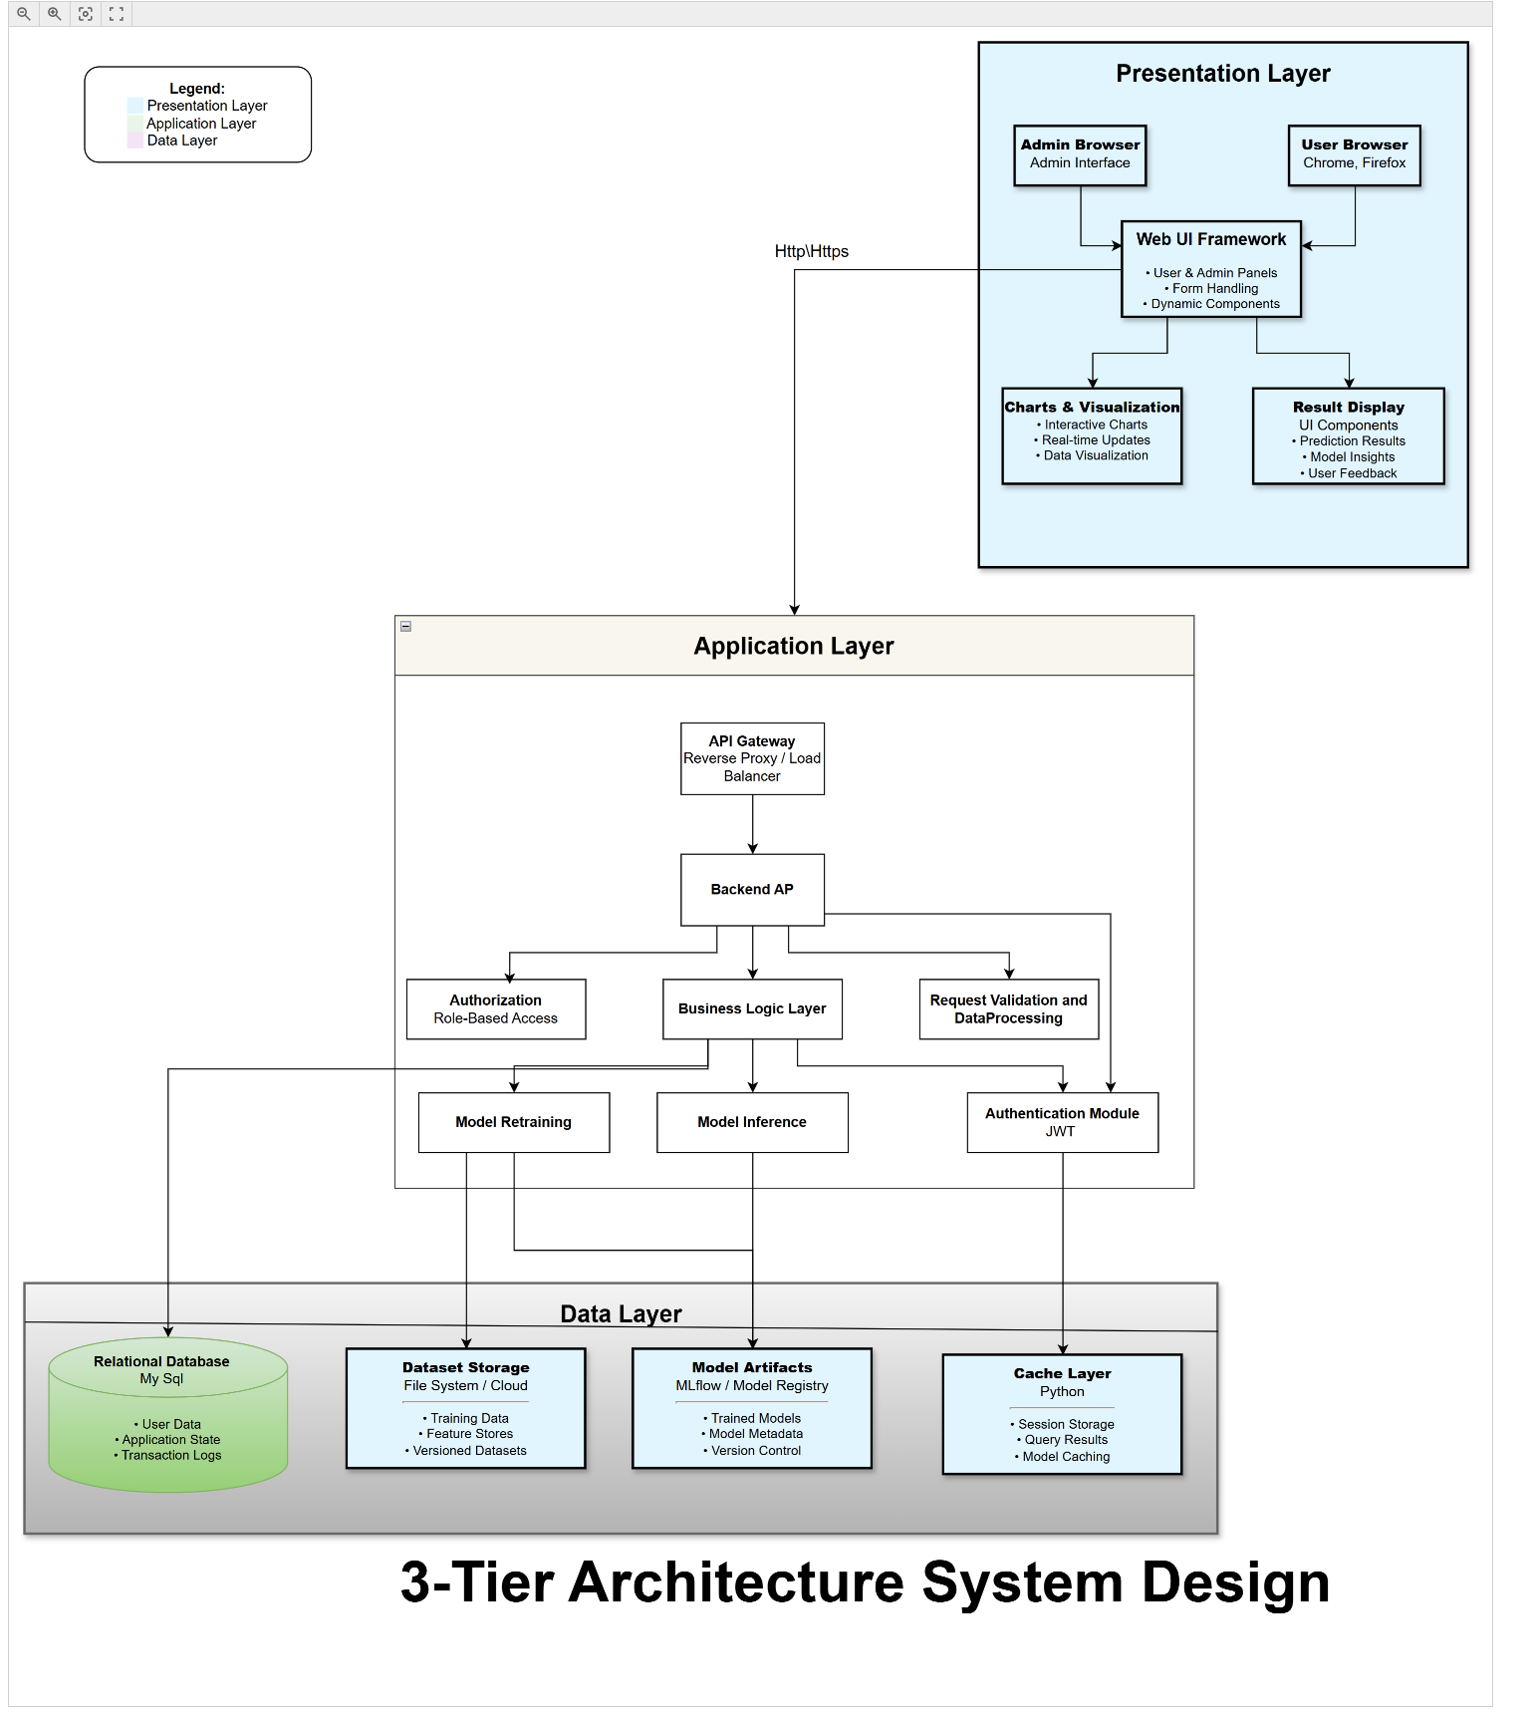

- Class Diagram

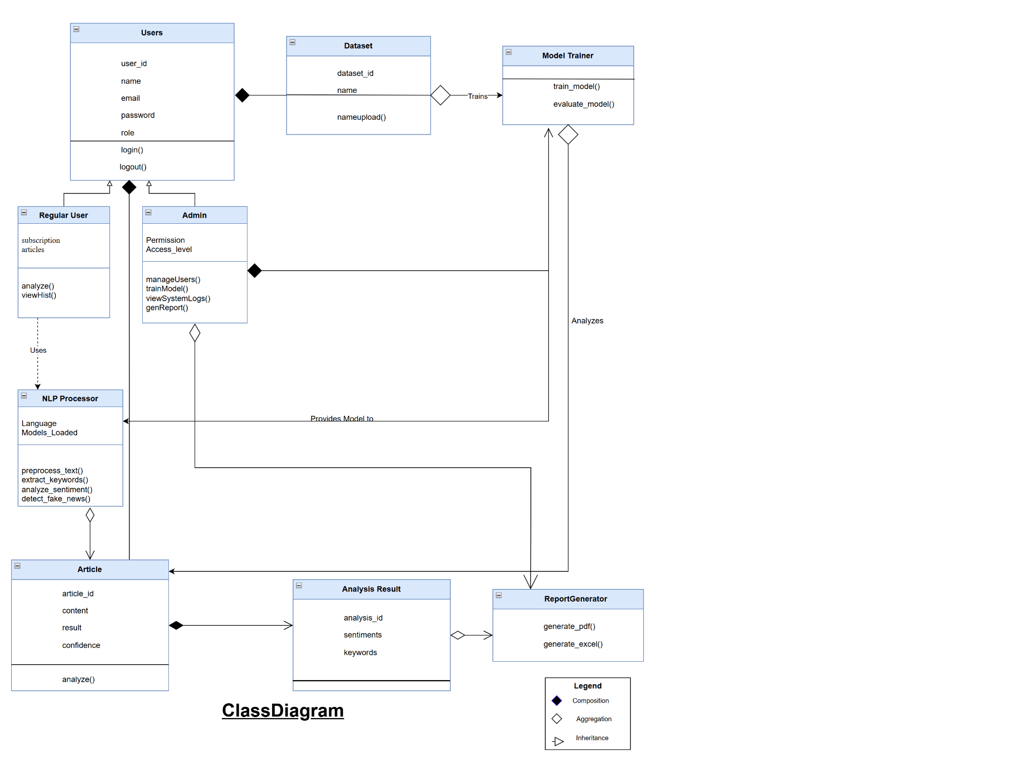

- Database Design

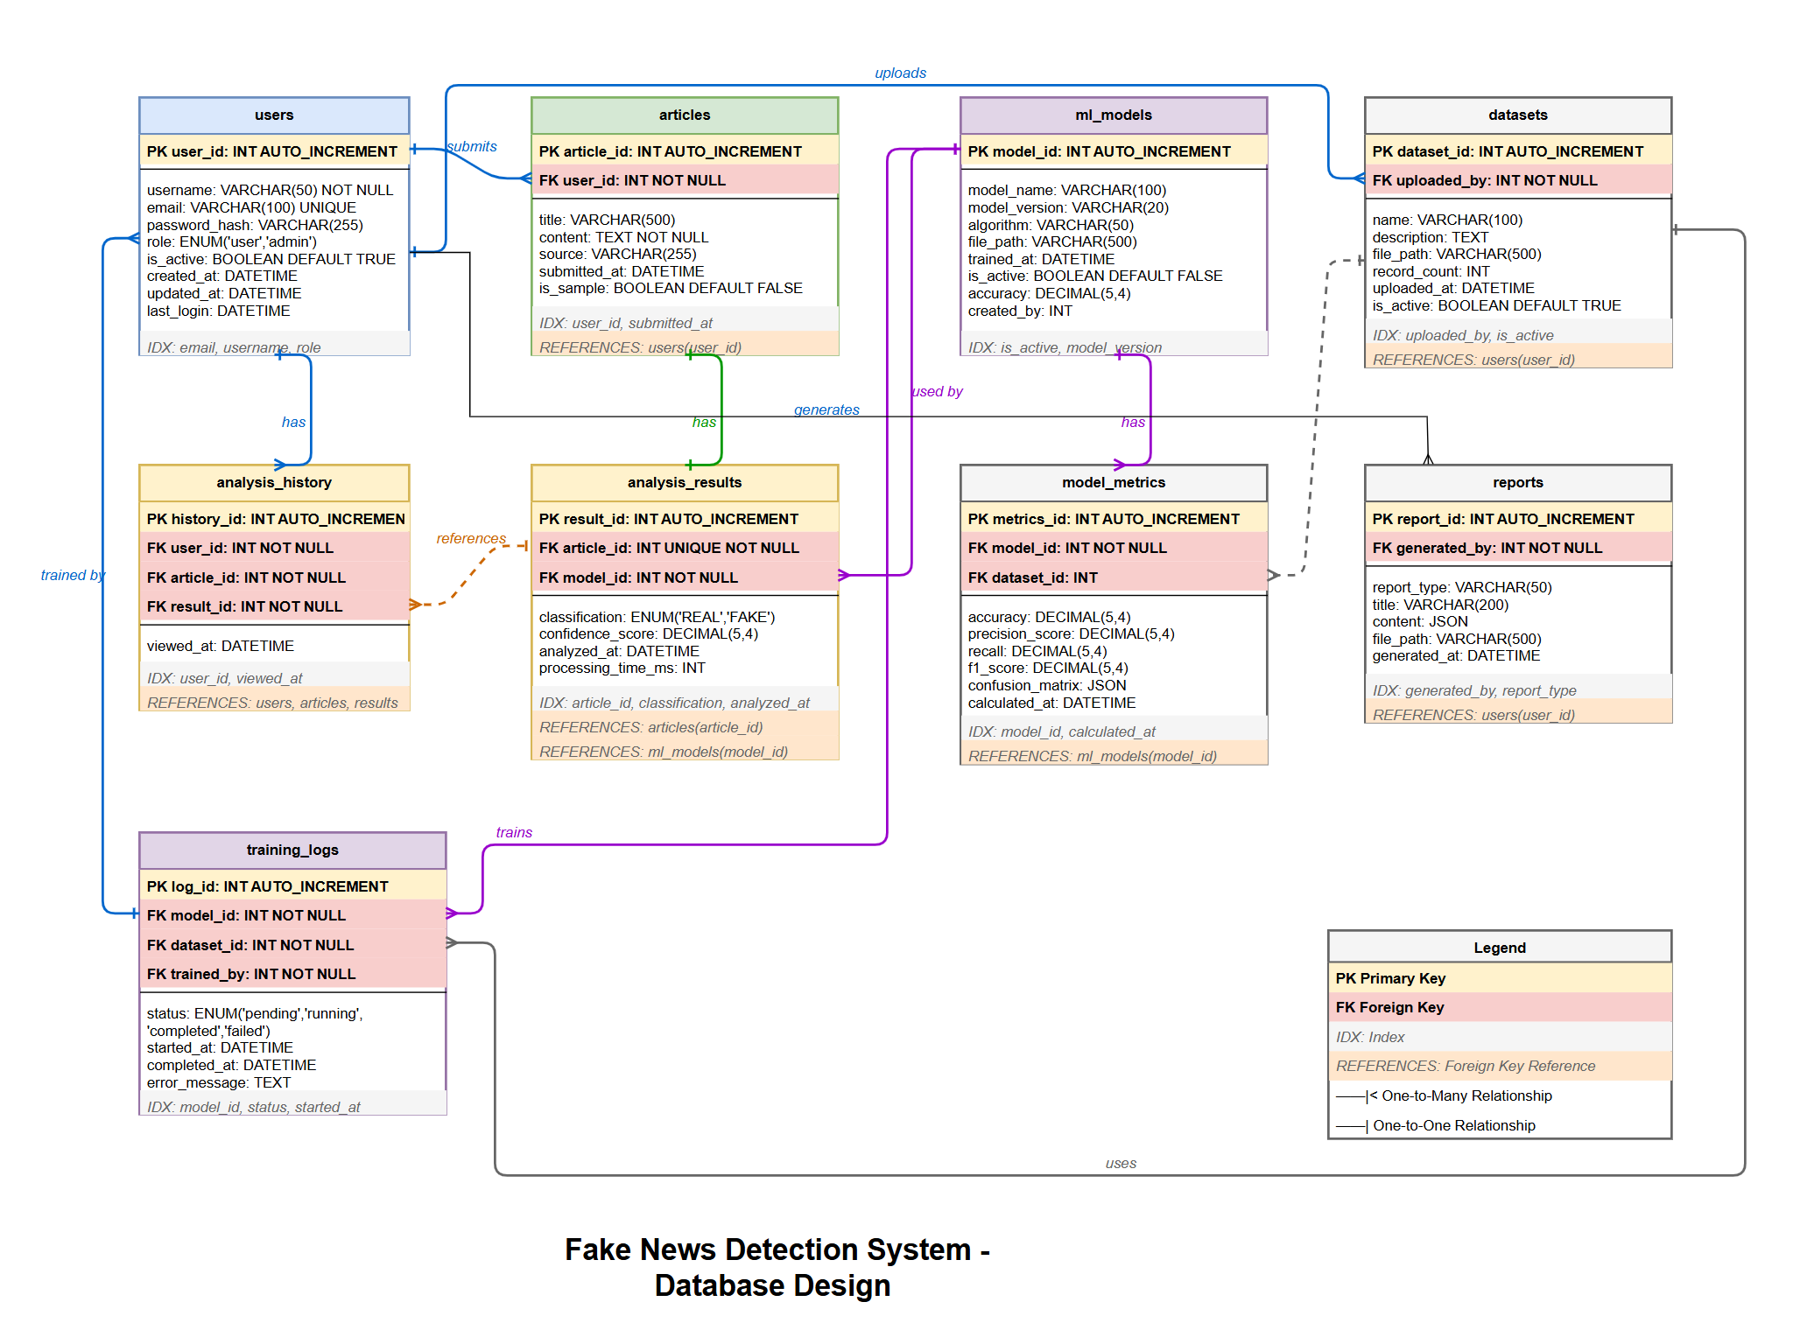

- Interface Design
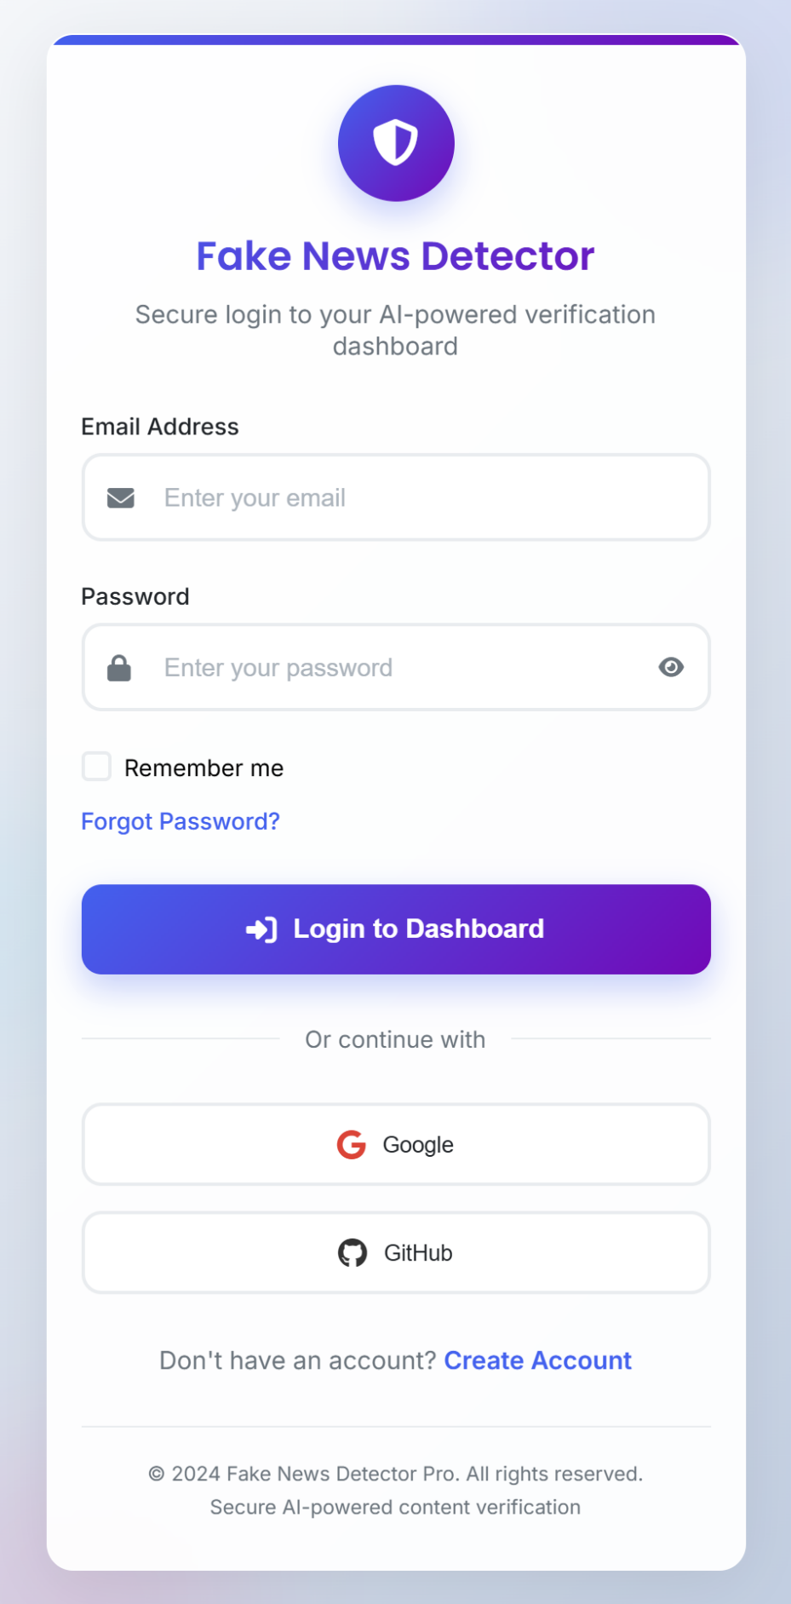

  - Main Page
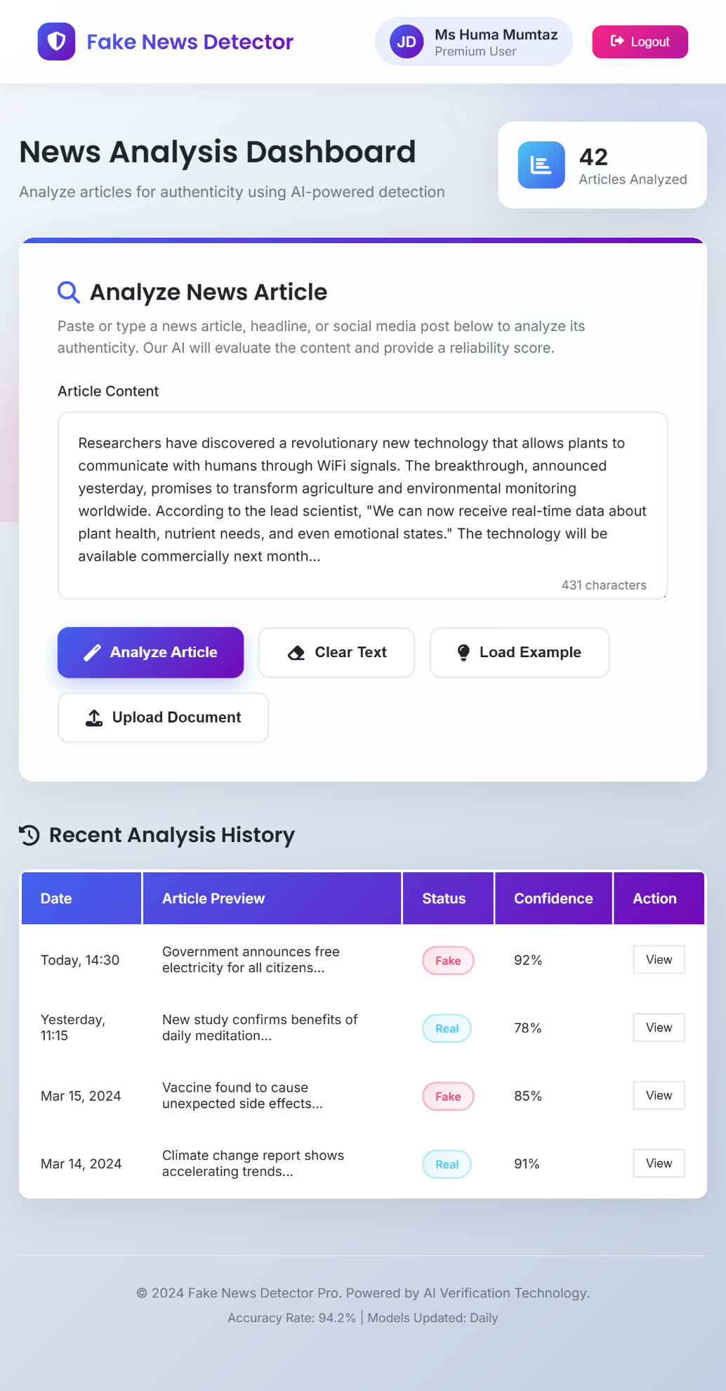

- User Dashboard

- Admin Dashboard
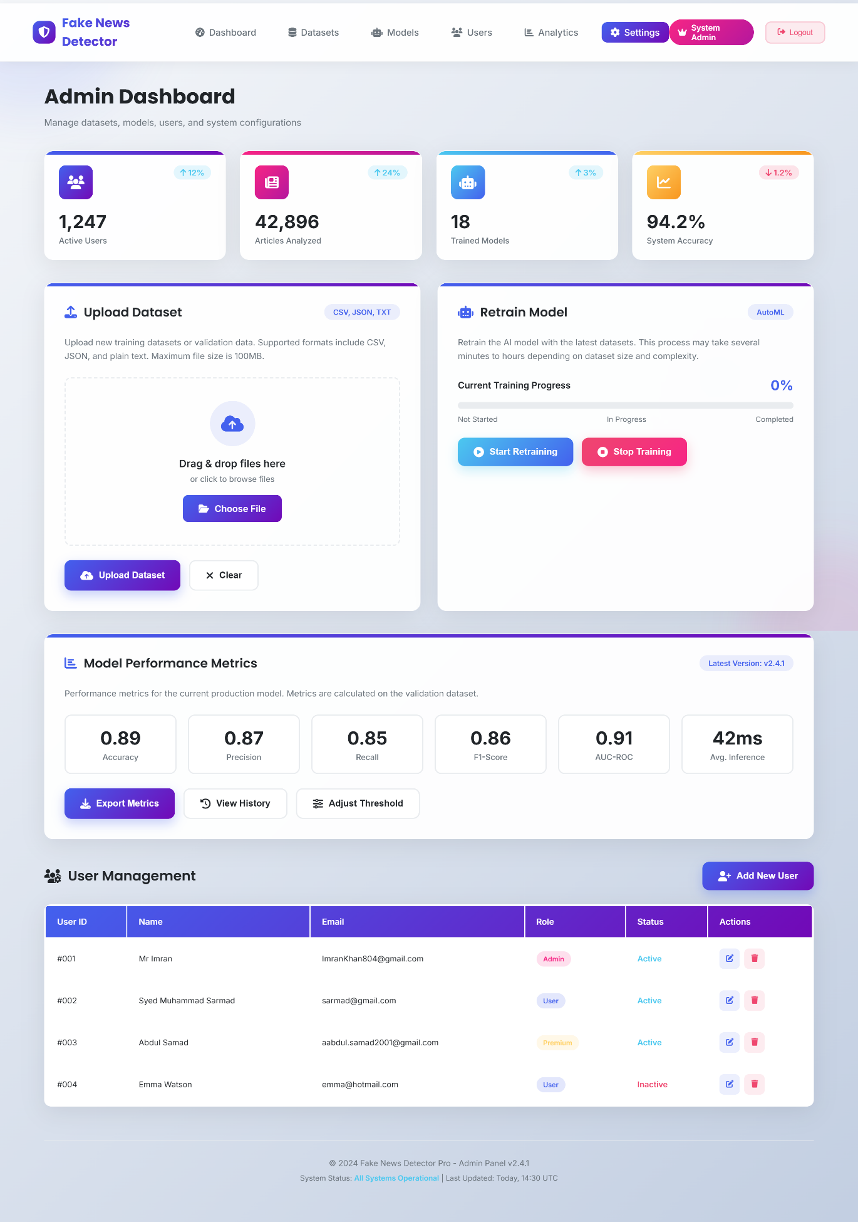
- Test Cases

Use Case: Login (UC-01)

TC ID | Use Case ID | Preconditions | Test Steps | Test Data | Expected Result | Pass Criteria
TC-01 | UC-01 Login | User/Admin registered | 1. Open login page | Valid credentials | User/Admin redirected to dashboard | Dashboard displayed successfully
 |  |  | 2. Enter valid email & password
 |  |  | 3. Click Login
TC-02 | UC-01 Login | User registered | Enter invalid password | Valid email, wrong password | Error message displayed | No login, error shown
TC-03 | UC-01 Login | User registered | Click “Forgot Password” | Registered email | Reset link sent | Reset email delivered
TC-04 | UC-01 Login | User registered | Try login when DB unavailable | Valid credentials | Login fails | System shows DB error

Use Case: Manage Users (UC-02)

TC ID | Use Case ID | Preconditions | Test Steps | Test Data | Expected Result | Pass Criteria
TC-05 | UC-02 Manage Users | Admin logged in | Add new user | New user details | User added successfully | User exists in DB
TC-06 | UC-02 Manage Users | Admin logged in | Update existing user | Modified user data | User updated | Updated data saved
TC-07 | UC-02 Manage Users | Admin logged in | Delete user | user_id | User removed | User no longer exists
TC-08 | UC-02 Manage Users | Admin logged in | Add user with duplicate email | Existing email | Warning message | User not created

Use Case: Upload Dataset (UC-03)

TC ID | Use Case ID | Preconditions | Test Steps | Test Data | Expected Result | Pass Criteria
TC-09 | UC-03 Upload Dataset | Admin logged in | Upload valid dataset | CSV file | Dataset uploaded | Dataset stored
TC-10 | UC-03 Upload Dataset | Admin logged in | Upload invalid file | .exe file | Upload rejected | Error displayed
TC-11 | UC-03 Upload Dataset | Admin logged in | Upload corrupted file | Corrupted CSV | Upload failed | Error message

Use Case: Retrain Model (UC-04)

TC ID | Use Case ID | Preconditions | Test Steps | Test Data | Expected Result | Pass Criteria
TC-12 | UC-04 Retrain Model | Dataset available | Click Retrain | Valid dataset | Model retrained | New model stored
TC-13 | UC-04 Retrain Model | Dataset available | Cancel training | — | Training stopped | No model updated
TC-14 | UC-04 Retrain Model | Dataset available | Training exceeds limits | Large dataset | Training fails | Timeout error shown

Use Case: View Metrics (UC-05)

TC ID | Use Case ID | Preconditions | Test Steps | Test Data | Expected Result | Pass Criteria
TC-15 | UC-05 View Metrics | Model trained | Open metrics page | — | Metrics displayed | Correct values shown
TC-16 | UC-05 View Metrics | No model trained | Open metrics page | — | Warning shown | No metrics displayed

Use Case: Generate Reports (UC-06)

TC ID | Use Case ID | Preconditions | Test Steps | Test Data | Expected Result | Pass Criteria
TC-17 | UC-06 Generate Reports | Admin logged in | Select report type | Usage report | Report generated | File downloadable
TC-18 | UC-06 Generate Reports | Admin logged in | Generate report with no data | — | Empty report | Report generated successfully

Use Case: Manage Analysis History (UC-07)

TC ID | Use Case ID | Preconditions | Test Steps | Test Data | Expected Result | Pass Criteria
TC-19 | UC-07 Manage History | Admin logged in | View history | — | History shown | Records displayed
TC-20 | UC-07 Manage History | Admin logged in | Delete history item | article_id | Record deleted | History updated
TC-21 | UC-07 Manage History | Admin logged in | Delete with DB error | article_id | Error shown | Record not deleted

Use Case: Register (UC-08)

TC ID | Use Case ID | Preconditions | Test Steps | Test Data | Expected Result | Pass Criteria
TC-22 | UC-08 Register | None | Submit valid registration | Valid details | Account created | User saved in DB
TC-23 | UC-08 Register | None | Register with existing email | Existing email | Error message | Account not created

Use Case: Input News (UC-09)

TC ID | Use Case ID | Preconditions | Test Steps | Test Data | Expected Result | Pass Criteria
TC-24 | UC-09 Input News | User logged in | Enter news text & submit | Valid news text | Text accepted | Sent for analysis
TC-25 | UC-09 Input News | User logged in | Submit empty text | Empty | Validation error | Text rejected

Use Case: Receive Classification Result (UC-10)

TC ID | Use Case ID | Preconditions | Test Steps | Test Data | Expected Result | Pass Criteria
TC-26 | UC-10 Receive Result | Model trained | Analyze news | Sample news | Fake/Real shown | Confidence displayed
TC-27 | UC-10 Receive Result | Model not trained | Analyze news | Valid input | Error shown | No result displayed

Use Case: View User History (UC-11)

TC ID | Use Case ID | Preconditions | Test Steps | Test Data | Expected Result | Pass Criteria
TC-28 | UC-11 View History | User logged in | Open history page | — | History displayed | Records shown
TC-29 | UC-11 View History | User logged in | View empty history | — | No records message | Proper message shown

Use Case: View Graphs (UC-12)

TC ID | Use Case ID | Preconditions | Test Steps | Test Data | Expected Result | Pass Criteria
TC-30 | UC-12 View Graphs | Analysis exists | Open graphs | — | Charts displayed | Correct visualization
TC-31 | UC-12 View Graphs | No analysis | Open graphs | — | Warning shown | No chart rendered

Use Case: Export Results (UC-13)

TC ID | Use Case ID | Preconditions | Test Steps | Test Data | Expected Result | Pass Criteria
TC-32 | UC-13 Export Results | Results exist | Export PDF | result_id | File downloaded | Valid PDF
TC-33 | UC-13 Export Results | Results exist | Export Excel | result_id | File downloaded | Valid Excel
TC-34 | UC-13 Export Results | Results exist | Cancel export | — | Export cancelled | No file generated

